GRAMMAR GENIUS WITH AI
Project report submitted in partial fulfillment of the requirement for the award of the degree of Master of Computer Applications
By
GUNRATI NAVANEETHA
(Roll No: 1251-23-862-243)
Under the guidance of
Ms. BNS HEMALATHA ASST PROFESSOR

Wesley Post-Graduate College
(A Christian Minority Institution)
145, Mc Intyre Road, Secunderabad – 500003.
(Affiliated to Osmania University and Approved by A.I.C.T.E)
2023-2025

CERTIFICATE

This is to certify that Mr/Miss GUNRATI NAVANEETHA bearing Hall Ticket Number 1251-23-862-243 have developed the software project entitled “GRAMMAR GENIUS WITH AI” ,as partial fulfillment for the award of the degree of MASTER OF COMPUTER APPLICATIONS during the academic year 2023-2025

INTERNAL GUIDE EXTERNAL EXAMINE

Head of Department DIRECTOR

ACKNOWLEDGEMENTS

The successful completion of any task would be incomplete without the mention of people who made it possible through their constant guidance and encouragement.
I pay my sincere thanks to Prof. Dr. B. Vimal Sukumar, Director WESLEY PG COLLEGE for providing me with all the necessary amenities.
I wish to express my profound deep sense of gratitude to Mr. P. M. Yohan, Head of the Department, WESLEY PG COLLEGE for his effective encouragement and enthusiastic guidance for the successful completion of my project work.
I am also indebted to my project guide Ms. BNS HEMALATHA ASST PROFESSOR for his/her continuous support and valuable suggestions for successful completion of my project work.
I take this opportunity to acknowledge the importance of other faculty members in our department for their kindness and timely helping during my project work.

DECLARATION

I hereby declare that the project work entitled “GRAMMAR GENIUS WITH AI” submitted to Osmania University, is a record of an original work done by me under the guidance of Mr/Ms BNS HEMALATHA ASST PROFESSOR, and this project work is submitted in the partial fulfillment for the award of the degree of MASTER OF COMPUTER APPLICATIONS.
The results embodied in this thesis have not been submitted to any other University or Institute for the award of any degree or diploma.

Place: Secunderabad GUNRATI NAVANEETHA

Date: (1251-23-862-243)
ABSTRACT

OBJECTIVE

The objective of the “Grammar Genius with AI” project is to develop an intelligent application that assists users in improving their writing skills by providing instant grammar checks, style suggestions, and context-based recommendations. The goal is to enhance both the quality and clarity of written content through AI-powered corrections, enabling users to communicate more effectively.

SCOPE OF THE PROJECT

The scope of this project covers
1. Grammar checking and correction.
2. Sentence structure enhancement.
3. Stylistic improvements for clarity and coherence.
4. Real-time suggestions for better vocabulary and word choices.
5. Support for multiple languages.
6. Integration with popular text editors (e.g., Microsoft Word, Google Docs) and web browsers for easy accessibility.
7. User-friendly interface with feedback mechanisms.
8. Providing educational insights on common writing mistakes.
9. Scalable backend to handle large numbers of users.

EXISTING SYSTEM

Currently, many grammar-checking tools exist, such as Grammarly and ProWritingAid, that provide basic grammar checks and writing suggestions. However, they often lack deep context-based understanding, are limited in providing personalized feedback, or fail to address nuanced stylistic improvements. These tools also tend to be reactive, offering suggestions only after the text is input, without the ability to continuously enhance writing as it develops.

PROPOSED SYSTEM

The proposed Grammar Genius with AI system aims to address the limitations of existing systems by offering:
1. Context-Aware Feedback: Using advanced machine learning models, the system will provide more accurate, context-based grammar and style suggestions. 2. Real-time Assistance: It will offer instant grammar corrections and stylistic improvements while the user writes.
3. Personalized Suggestions: Based on user preferences, the system will offer tailored feedback, learning from the user’s writing style and preferences.
4. AI-Driven Learning: The system will continuously improve its recommendations based on user interaction, providing more accurate insights over time.
5. Multilingual Support: The system will be able to handle multiple languages and provide grammar checking across various linguistic contexts.

SOFTWARE REQUIREMENTS

- Programming Languages: Python, JavaScript
- Frameworks/Libraries: TensorFlow, spaCy, NLTK, ReactJS, Node.js
- Database: MySQL or MongoDB
- Cloud Platform: AWS, Google Cloud, or Azure for deployment and storage
- Development Tools: Visual Studio Code, Jupyter Notebook (for model development)
- Third-Party APIs: Grammarly API, LanguageTool API (if necessary for grammar correction)
- Version Control: Git and GitHub for source code management

HARDWARE REQUIREMENTS

1. Processor: Intel i5/i7 or equivalent
2. RAM: 8 GB or more
3. Storage: Minimum 100 GB of free space for application storage and databases 4. Graphics Card: For deep learning models, a GPU (NVIDIA or equivalent) is preferred, especially for model training
5. Internet Connection: Stable high-speed internet connection for cloud access and API integrations

INDEX
S.NO |  |  | TABLE OF CONTENT |  | PAGE NO
 |  |  | INTRODUCTION
 | 1.1 |  | Introduction to project
 | 1.2 |  | Purpose of the project
 | 1.3 |  | Existing system and its disadvantages
 | 1.4 |  | Proposed system and its advantages
 |  |  | SYSTEM ANALYSIS
 | 2.1 |  | Study of the system
 | 2.2 |  | System architecture
 |  |  | FEASIBILITY STUDY
 | 3.1 |  | Technical Feasibility
 | 3.2 |  | Operational Feasibility
 | 3.3 |  | Economic Feasibility
 |  |  | SOFTWARE REQUIREMENT SPECIFICATION
 | 4.1 |  | Functional requirements
 | 4.2 |  | Performance requirements
 | 4.3 |  | Hardware requirements
 | 4.4 |  | Software requirements
 | 4.4.1 |  | Introduction to java/.net
 | 4.4.2 |  | Any other technologies used in your project
 |  |  | SYSTEM DESIGN
 |  |  | Introduction
 |  |  | DFDs
 |  |  | UML Diagram
 |  |  | Class diagram
 |  |  | Sequence and Collaboration Diagram
 |  |  | Usecase diagram
 |  |  | E-R Diagram
 |  |  | Data Dictionary
 |  |  | CODING
 |  |  | TESTING
 | 7.1 |  | Introduction to testing
 |  | 7.2 |  | Testing Strategies
 |  |  |  | OUTPUT SCREENS
 |  |  |  | CONCLUSION
 |  |  |  | FURTHER ENHANCEMENTS
 |  |  |  | REFERENCES/BIBLIOGRAPHY

CHAPTER -1
INTRODUCTION
1.1 Introduction to project
As artificial intelligence continues to grow, its impact on grammar and language is becoming more important. Since a lot of our communication now happens online, using clear and correct grammar is essential. This has encouraged researchers and developers to find ways AI can help improve grammar and make writing easier for everyone.

AI can help make grammar more accurate and improve our understanding of language. It can also shape the way we learn and use language in the future. By providing real-time corrections and explanations, AI tools can make writing more effective and accessible for people of all backgrounds.

In the future, AI-powered grammar tools could become an essential part of education and professional communication. These tools will not only correct mistakes but also help users learn and improve their writing skills over time. As AI continues to develop, it will play a bigger role in making language learning more interactive and personalized for everyone.
1.2 Purpose of the Project
1. Improve writing accuracy: By detecting and correcting grammatical errors, the tool helps users produce error-free content.
2. Enhance writing clarity: By suggesting alternative phrases and sentence structures, the tool improves the overall coherence and readability of the text.
3. Assist language learners and non-native speakers: The tool provides valuable support for individuals who are learning English or are non-native speakers, helping them to communicate more effectively.
4. Increase productivity: By automating the proofreading process, the tool saves users time and effort, allowing them to focus on more important tasks.

Overall, the Grammar Genius with Artificial Intelligence project aims to provide a valuable resource for individuals looking to improve their writing skills and produce high-quality content.
1.3 Existing system

The existing system for grammar checking and correction typically involves:
1. Manual proofreading: Human editors or writers review and correct text manually.
2. Grammar checking tools: Software tools like Grammarly, Ginger, or built-in grammar checkers in word processors.

Disadvantages

1. Limited accuracy: Existing tools may not always detect errors accurately, especially for complex sentences or nuanced language.
2. Lack of context understanding: Tools may not fully understand the context, leading to incorrect suggestions.
3. Limited feedback: Some tools provide limited feedback, focusing only on grammar and spelling errors.
4. Dependence on rules-based approach: Many existing tools rely on pre-defined rules, which may not account for language evolution or exceptions.
5. Insufficient support for non-native speakers: Existing tools may not provide adequate support for language learners or non-native speakers.

These limitations highlight the need for a more advanced and intelligent system like Grammar Genius with Artificial Intelligence.

1.4 Proposed System

Grammar Genius with Artificial Intelligence
The proposed system leverages advanced AI and NLP techniques to provide:

1. Accurate grammar and spell checking
2. Contextual understanding: AI-powered system understands the context, providing more accurate suggestions.
3. Personalized feedback: System provides tailored feedback and suggestions for improvement.
4. Advanced language analysis: System analyzes sentence structure, syntax, and semantics.

Advantages

- Improved accuracy: AI-powered system detects errors more accurately.
- Enhanced user experience: Personalized feedback and suggestions improve user engagement.
- Increased efficiency: Automated system saves time and effort.
- Support for non-native speakers: System provides valuable assistance for language learners.
- Continuous learning: AI-powered system learns from data, improving over time.
CHAPTER – 2
SYSTEM ANALYSIS

2. SYSTEM ANALYSIS

It is essential for understanding how Grammar Genius with AI will function and meet user needs. This involves examining the system’s components, processes, and how they interact to deliver grammar correction and writing assistance.
User Requirements
- Students: Need grammar correction and learning support.
- Professionals: Require polished and error-free writing for emails and reports.
- Content Creators: Benefit from style suggestions and vocabulary enhancements.
- General Users: Want easy-to-use grammar correction for daily writing tasks.
Functional Requirements
- Grammar & Punctuation Check: Detects and corrects grammatical errors.
- Sentence Structure Improvement: Suggests better sentence formation.
- Real-Time Feedback: Provides instant corrections as users type.
- Style & Tone Analysis: Enhances writing based on context and audience.
- Plagiarism Detection: Ensures originality of content.
- Multilingual Support: Assists users in multiple languages.
Non-Functional Requirements
- User-Friendly Interface: Simple and intuitive design.
- Fast Processing Speed: Quick grammar checking and feedback.
- Security & Privacy: Ensures user data is protected.
- Cross-Platform Compatibility: Works on web, mobile, and desktop applications.
System Components
- User Interface (UI): Web and mobile interfaces for user interaction.
- AI Engine: NLP-based algorithm for grammar and writing analysis.
- Database: Stores user data, corrections, and preferences.
- Cloud Integration: Enables real-time processing and data synchronization. Expected Outcome
Grammar Genius with AI will provide an efficient and intelligent writing assistant that enhances grammar accuracy, improves writing style, and offers educational insights

2.1 Study of the system
1. Literature Review: Analyzing existing research on AI-powered grammar checking and language learning systems.
2. System Design: Designing the architecture and components of the Grammar Genius system.
3. AI Model Development: Developing and training AI models for grammar checking, syntax analysis, and personalized feedback.
4. System Evaluation: Evaluating the system's performance, accuracy, and user experience.
5. User Testing: Conducting user testing to gather feedback and identify areas for improvement.

Key Aspects
1. Natural Language Processing (NLP): Understanding the role of NLP in grammar checking and language analysis.
2. Machine Learning: Applying machine learning algorithms to improve system accuracy and performance.
3. User Interface: Designing an intuitive and user-friendly interface for Grammar Genius.

The study aims to

1. Improve system performance: Enhance accuracy, efficiency, and user experience.
2. Inform system development: Guide the development of Grammar Genius with insights from literature review, user testing, and system evaluation.

By conducting a thorough study, we can ensure that Grammar Genius is a robust, effective, and user-friendly system.

2.2 SYSTEM ARCHITECTURE
Grammar Genius with Artificial Intelligence
The system architecture consists of:

Components
1. User Interface (UI): A user-friendly interface for inputting text and receiving feedback.
2. Natural Language Processing (NLP) Module: Analyzes text using NLP techniques, such as tokenization, part-of-speech tagging, and syntax analysis.
3. Grammar Checking Module: Identifies grammatical errors and suggests corrections.
4. AI Model: Utilizes machine learning algorithms to improve accuracy and provide personalized feedback.
5. Database: Stores user data, feedback, and system updates.

Workflow
1. Text Input: User inputs text through the UI.
2. NLP Analysis: NLP module analyzes the text.
3. Grammar Checking: Grammar checking module identifies errors and suggests corrections.
4. AI-powered Feedback: AI model provides personalized feedback and suggestions.
5. Output: System displays feedback and suggestions to the user.

Key Technologies
1. Machine Learning: Utilizes machine learning algorithms for AI-powered feedback.
2. NLP: Employs NLP techniques for text analysis.
3. Cloud-based: Can be deployed on cloud platforms for scalability and accessibility.

The system architecture is designed to provide an efficient, accurate, and user-friendly experience for Grammar Genius users.
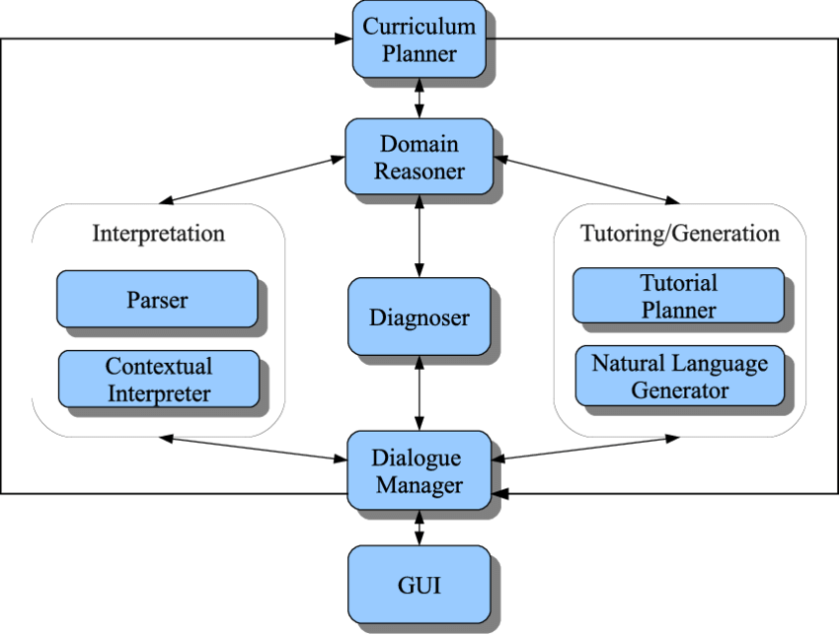

SYSTEM ARCHITECTURE

CHAPTER – 3
FEASIBILITY STUDY

3. FEASIBILITY STUDY
Feasibility Study for Grammar Genius with Artificial Intelligence

3.1 Technical Feasibility

1. AI and NLP capabilities: Assess the availability and effectiveness of AI and NLP technologies.
2. Integration with existing systems: Evaluate the feasibility of integrating Grammar Genius with existing systems.

3.2 Operational Feasibility

1. User adoption: Determine the likelihood of user adoption and acceptance.
2. Training and support: Assess the need for training and support for users.

3.3 Economic Feasibility

1. Development costs: Estimate the costs associated with developing Grammar Genius.
2. Maintenance and update costs: Determine the ongoing costs for maintaining and updating the system.
3. Potential revenue streams: Identify potential revenue streams, such as subscription-based models.

3.4 Schedule Feasibility

1. Project timeline: Develop a project timeline and milestones.
2. Resource allocation: Determine the resources required for the project.

The feasibility study will help determine whether Grammar Genius is a viable project, identifying potential challenges and opportunities.

CHAPTER – 4
SOFTWARE REQUIREMENT SPECIFICATION

4. SOFTWARE REQUIREMENT SPECIFICATION

Software Requirement Specification (SRS) for Grammar Genius with Artificial Intelligence
Introduction
1. Purpose: Define the purpose and scope of the SRS.
2. Audience: Identify the target audience for the SRS.

4.1 Functional Requirements
Functional Requirements of Grammar Genius with Artificial Intelligence
Key Features
1. Grammar and Spell Checking: Accurate detection and correction of grammatical errors.
2. AI-powered Feedback: Personalized suggestions for improvement.
3. Syntax Analysis: Analysis of sentence structure and syntax.
4. User Interface: Intuitive and user-friendly interface.
5. Text Analysis: Analysis of text for clarity, coherence, and style.

Functional Requirements
1. Input Text: System accepts text input from users.
2. Analyze Text: System analyzes text for grammar, syntax, and style.
3. Provide Feedback: System provides personalized feedback and suggestions.
4. User Profile Management: System manages user profiles and preferences.
5. Error Reporting: System reports errors and provides correction suggestions.

4.2 Performance Requirements

1. Accuracy: System provides accurate grammar and spell checking.
2. Speed: System responds quickly to user input.
3. Scalability: System handles large volumes of user data.

These functional requirements outline the key features and capabilities of Grammar Genius, ensuring it meets user needs and expectations.

4.3 Hardware Requirements

Hardware Requirements for Grammar Genius with Artificial Intelligence
Server Requirements
1. Processor: Multi-core processor (e.g., Intel Core i5 or i7)
2. Memory: 8 GB or more RAM
3. Storage: 256 GB or more SSD storage

Client Requirements
1. Device: Desktop, laptop, or mobile device
2. Browser: Modern web browser (e.g., Google Chrome, Mozilla Firefox)
3. Internet Connection: Stable internet connection

Additional Requirements
1. GPU: Optional GPU acceleration for AI model training
2. Cloud Infrastructure: Cloud hosting for scalability and reliability

These hardware requirements ensure smooth operation and optimal performance of Grammar Genius.

4.4 Software Requirements

Software Requirements for Grammar Genius with Artificial Intelligence
Programming Languages

1. Python: For AI and NLP development
2. JavaScript: For front-end development and user interface

Frameworks and Libraries

1. NLTK: For natural language processing
2. spaCy: For advanced NLP capabilities
3. TensorFlow or PyTorch: For AI model development
4. React or Angular: For front-end framework

Database Management

1. Relational Database: MySQL or PostgreSQL
2. NoSQL Database: MongoDB or Cassandra

Operating System

1. Windows: For development and deployment
2. Linux: For server-side deployment

Additional Requirements

1. Cloud Platform: AWS, Google Cloud, or Microsoft Azure
2. Version Control: Git for source code management

These software requirements support the development and deployment of Grammar Genius with Artificial Intelligence.

4.4.1 Introduction to java/.net

Java/.NET in Grammar Genius with Artificial Intelligence
Java
1. NLP libraries: Java can utilize libraries like Stanford CoreNLP for natural language processing.
2. Machine learning integration: Java can integrate with machine learning frameworks like Weka or Deeplearning4j.
3. Android app development: Java can be used to develop Android apps for Grammar Genius.

.NET
1. NLP libraries: .NET can utilize libraries like Stanford.NLP.NET for natural language processing.
2. Machine learning integration: .NET can integrate with machine learning frameworks like ML.NET.
3. Windows app development: .NET can be used to develop Windows desktop applications for Grammar Genius.

Both Java and .NET can be used to develop Grammar Genius, leveraging their respective strengths in NLP, machine learning, and app development.

4.4.2 Any other technologies used in your project

Additional Technologies Used in Grammar Genius with Artificial Intelligence
Natural Language Processing (NLP) Tools

1. NLTK: For tokenization, stemming, and lemmatization.
2. spaCy: For advanced NLP capabilities, such as entity recognition and language modeling.

Machine Learning Frameworks

1. TensorFlow: For building and training AI models.
2. PyTorch: For building and training AI models.

Front-end Frameworks

1. React: For building the user interface and user experience.
2. Angular: For building complex web applications.

Database Management Systems

1. MySQL: For relational database management.
2. MongoDB: For NoSQL database management.

Cloud Platforms

1. AWS: For cloud infrastructure and services.
2. Google Cloud: For cloud infrastructure and services.

These additional technologies can enhance the functionality and performance of Grammar Genius, enabling advanced NLP capabilities, machine learning, and scalable infrastructure.

CHAPTER – 5
SYSTEM DESIGN

INTRODUCTION

Thus, in order to examine the design of this application, we first go through the specifics of establishing the concept of drone detection through a few fundamental modules that would clearly describe the workings of the system that would come from the development.

System design is a critical phase in the software development lifecycle that focuses on defining the architecture, components, modules, interfaces, and data for the Age and Gender Identification System. It serves as a blueprint for constructing the system, detailing how various elements will work together to meet functional and non-functional requirements. During this phase, architects and designers make decisions about the overall structure, including the choice of programming languages, frameworks, and tools that will be used. The design will include both high-level architecture, which outlines the system's general framework and interactions among components, and detailed design, which specifies the functionality of individual modules. User interface design will also be addressed to ensure an intuitive and accessible experience for users. Additionally, the system design will incorporate security measures, data flow, and error handling protocols to ensure robustness and reliability. By providing a clear and comprehensive design document, this phase facilitates effective communication among team members, guides implementation, and helps to mitigate risks associated with development. Ultimately, a well-conceived system design lays the foundation for a successful and efficient software solution.

DFDs
Data Flow Diagrams (DFDs) for Grammar Genius with Artificial Intelligence
Level 0 DFD (Context Diagram)
1. Entities: User, Grammar Genius System
2. Data Flows: User Input, Feedback, Suggestions

Level 1 DFD (Functional Decomposition)
1. Processes:
1. Text Analysis
2. Grammar and Spell Checking
3. AI-powered Feedback Generation
4. User Interface Management
2. Data Flows:
1. User Input to Text Analysis
2. Text Analysis to Grammar and Spell Checking
3. Grammar and Spell Checking to AI-powered Feedback Generation
4. AI-powered Feedback Generation to User Interface Management

Level 2 DFD (Detailed Processes)
1. Text Analysis: Tokenization, Part-of-Speech Tagging, Syntax Analysis
2. Grammar and Spell Checking: Grammar Rule Application, Spell Checking Algorithms
3. AI-powered Feedback Generation: Machine Learning Model Application, Feedback Generation

DFDs help visualize the flow of data within the Grammar Genius system, ensuring a clear understanding of the system's functionality and processes.

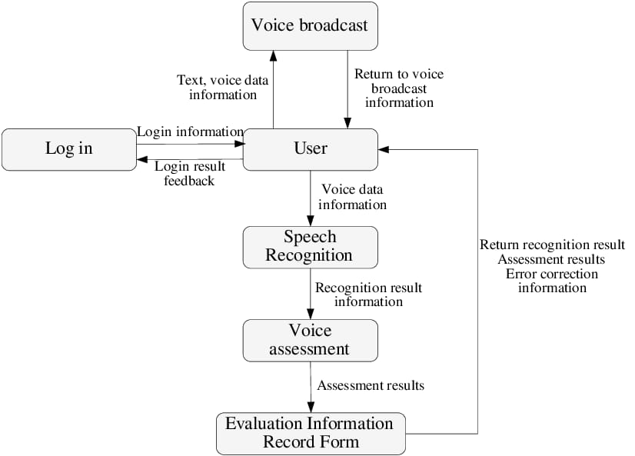

UML DIAGRAMS

Unified Modeling Language (UML) diagrams are graphical representations used in software engineering to visualize the structure, behavior, and interactions of a system. These diagrams help in understanding, designing, and communicating the system's architecture and functionality among stakeholders. UML diagrams can be categorized into several types, including structural diagrams such as class diagrams, object diagrams, and component diagrams, which depict the static structure of the system, including classes, objects, and their relationships. On the other hand, behavioral diagrams such as sequence diagrams, activity diagrams, and state diagrams illustrate the dynamic behavior and interactions within the system, showcasing how components collaborate to achieve specific functionalities. Additionally, deployment diagrams depict the physical deployment of software components across hardware nodes, while use case diagrams provide a high-level view of the system's functionalities from the user's perspective. Each UML diagram serves a specific purpose in capturing different aspects of the system, and collectively they offer a comprehensive representation of the system's architecture, behavior, and interactions.

Structural diagrams, such as class diagrams, showcase the classes within a system along with their attributes and relationships. Component diagrams illustrate the architecture by depicting the system's components and their dependencies. Composite structure diagrams provide insight into the internal structure of a class and its interactions, while deployment diagrams focus on the physical deployment of artifacts on hardware nodes. Object diagrams offer a snapshot of instances within the system at a specific point in time.

Interaction diagrams, such as timing diagrams, concentrate on the timing of messages and events over time, while communication diagrams emphasize the network of interactions rather than their sequence.

Using these UML diagrams will provide a comprehensive view of your age and gender identification system, helping both technical and non-technical stakeholders understand the system architecture and its functionalities. If you need more specific details or examples of any diagram.

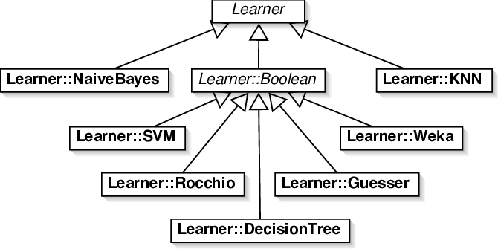

UML DIAGRAM

CLASS DIAGRAM

Class diagrams are the main building block of any object-oriented solution. It displays a system's classes, along with each class's properties, operations, and relationships to other classes. Most modelling tools include three elements to a class. Name is at the top, followed by attributes, then operations or methods, and finally, methods. Classes are linked together to generate class diagrams in a complex system with numerous related classes. Various sorts of arrows represent different relationships between classes.

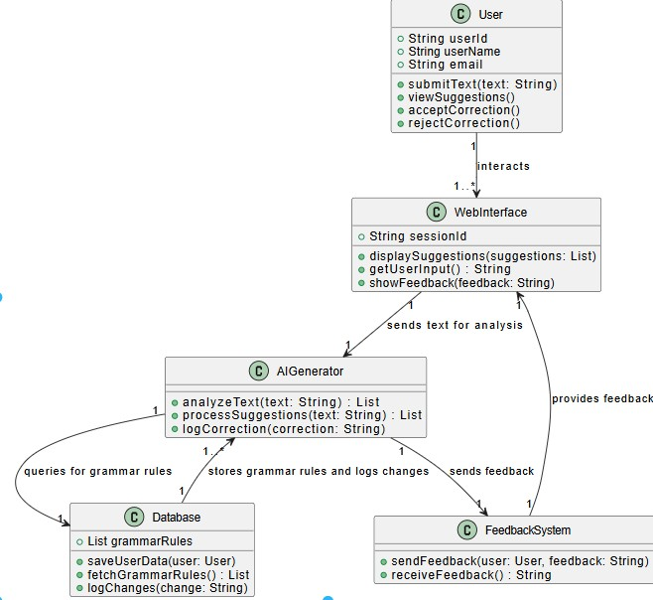

CLASS DIAGRAM

SEQUENCE DIAGRAM

In UML, sequence diagrams display how and in what order certain items interact with one another. It's crucial to remember that they depict the interactions for a certain circumstance. The interactions are depicted as arrows, while the processes are portrayed vertically. The objective of sequence diagrams and their fundamentals are explained in this article. To understand more about sequence diagrams, you may also look at this comprehensive tutorial.
In a sequence diagram, the main components include actors, objects, and messages. Actors represent external entities that interact with the system, while objects represent the components or classes within the system. The diagram is laid out in a time-ordered fashion, with vertical lines representing the lifelines of objects and horizontal arrows indicating the messages exchanged between them.
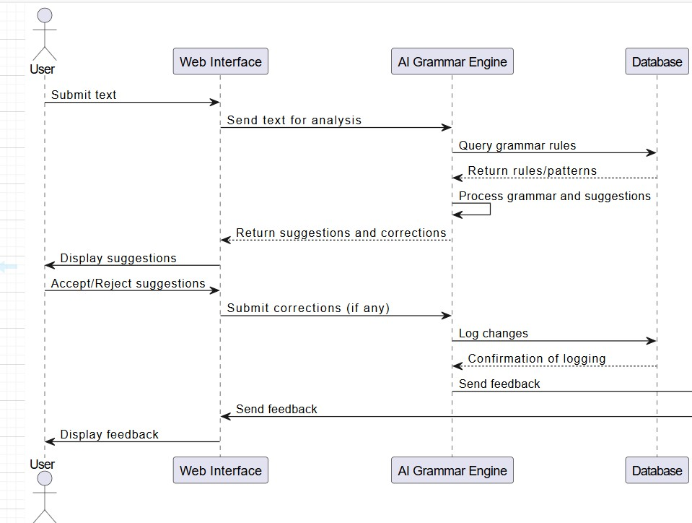

SEQUENCE DIAGRAM

COLLABORATION DIAGRAMS

Collaboration diagrams illustrate the interactions between objects in a system. For Grammar Genius with AI, these diagrams will show how different components work together to provide grammar checking, suggestions, and feedback.

Components

1. User Interface: Handles user input and displays results.
2. Grammar Checker: Analyzes text for grammatical errors.
3. AI Model: Provides suggestions and feedback based on grammar and context.
4. Database: Stores grammar rules, dictionaries, and user data.

Interactions

1. User Input: User submits text for analysis.
2. Grammar Analysis: Grammar Checker analyzes text and identifies errors.
3. AI-powered Suggestions: AI Model generates suggestions and feedback based on analysis.
4. Result Display: User Interface displays results, suggestions, and feedback.

Sequence of Interactions

1. User submits text through User Interface.
2. User Interface sends text to Grammar Checker.
3. Grammar Checker analyzes text and sends results to AI Model.
4. AI Model generates suggestions and feedback.
5. AI Model sends suggestions and feedback to User Interface.
6. User Interface displays results, suggestions, and feedback to user.

Collaboration diagrams help visualize the interactions between components in Grammar Genius with AI, ensuring a clear understanding of the system's functionality and workflow.

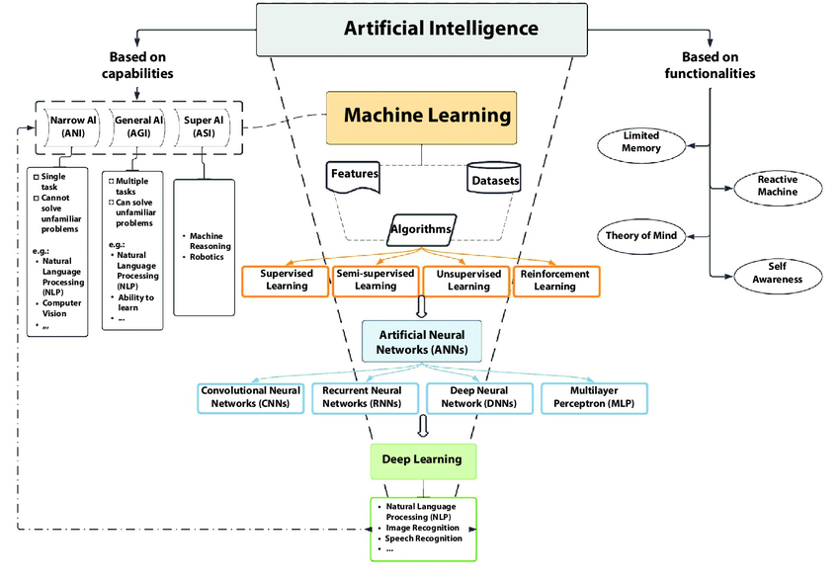

COLLABORATION DIAGRAM

USECASE DIAGRAM

To depict a system's dynamic behavior, use case diagrams are often employed. Using use cases, actors, and their interactions, it captures the functionality of the system. A system or subsystem of an application's necessary duties, services, and operations are modelled. It shows a system's high- level functionality as well as how a user interacts with that system.
In a use case model, each use case represents a specific functionality or service that the system offers. The model typically includes key elements such as actors, which represent the users or external systems that interact with the application, and use cases themselves, which describe the sequence of actions taken by the actor and the system to accomplish a goal. Each use case can detail various scenarios, including the main success scenario, alternative flows, and error conditions, allowing for a comprehensive understanding of how the system should behave under different circumstances.

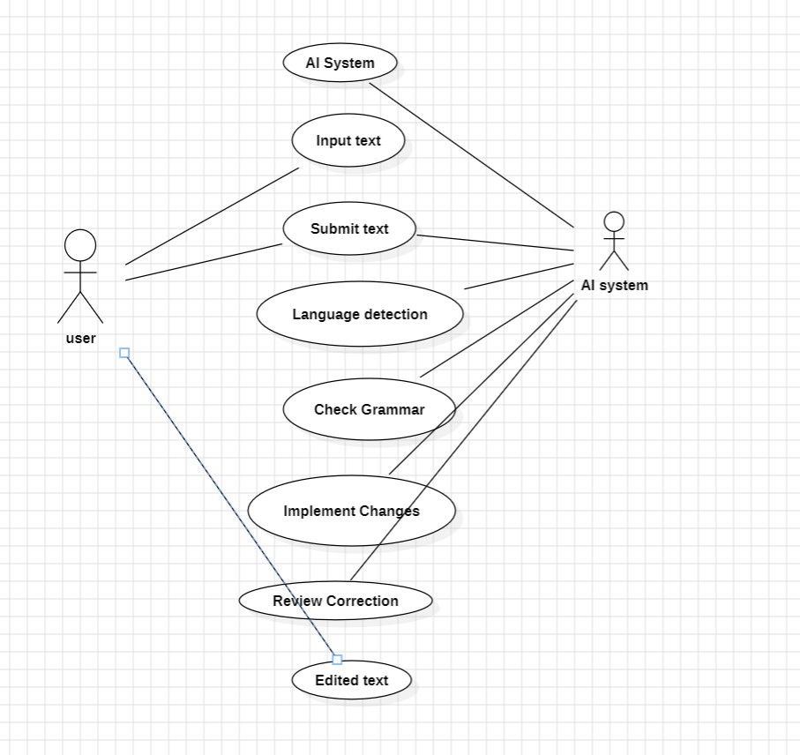

USECASE DIAGRAM

E – R DIAGRAM

1. User: Represents the user of the Grammar Genius system.
2. Text: Represents the text submitted for analysis.
3. Grammar Rule: Represents the grammar rules used for analysis.
4. Error: Represents the grammatical errors identified in the text.
5. Suggestion: Represents the suggestions provided by the AI model.

Relationships

1. User submits Text: A user can submit multiple texts for analysis (one-to-many).
2. Text is analyzed by Grammar Rule: A text is analyzed based on multiple grammar rules (many-to-many).
3. Error is identified in Text: An error can be identified in multiple texts (many-to-many).
4. Suggestion is provided for Error: A suggestion can be provided for multiple errors (many-to-many).
5. User receives Suggestion: A user can receive multiple suggestions (one-to-many).

Attributes

1. User: User ID, Name, Email
2. Text: Text ID, Content, Submission Date
3. Grammar Rule: Rule ID, Description, Category
4. Error: Error ID, Description, Location
5. Suggestion: Suggestion ID, Description, Recommendation

The ER diagram illustrates the relationships between entities in the Grammar Genius system, providing a clear understanding of the data structure and relationships.

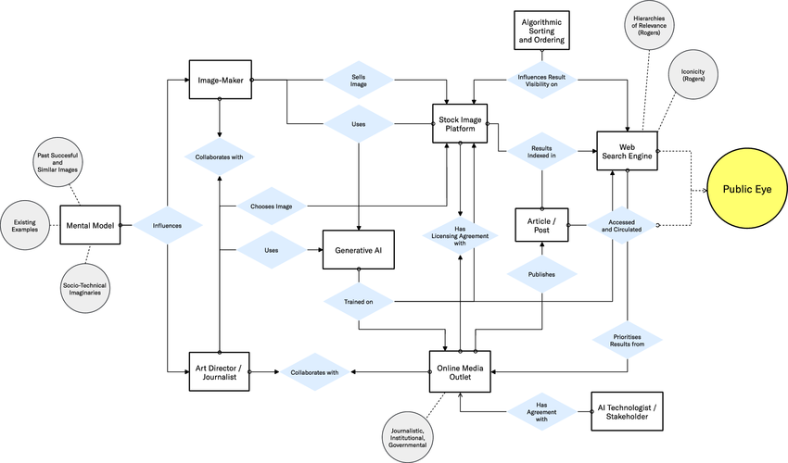

E – R DIAGRAMS

DATA DICTIONARY

To help you with a data dictionary for "Grammar Genius with AI", I’ll assume this is a software platform or app that uses artificial intelligence to help users improve their grammar. A data dictionary defines the structure, type, and description of data elements used in a system.
Below is a sample data dictionary for such an application. If you have specific features or a data model already, I can tailor this further.
Field Name | Data Type | Description | Example
user_id | UUID / String | Unique identifier for a registered user | 92f3e5ba-8f1c-4f98-bb2a-c70d6a2b87b9
username | String | Username chosen by the user | grammarninja88
email | String | Email address of the user | user@example.com
account_created | DateTime | Timestamp when the account was created | 2025-08-10T14:30:00Z
last_login | DateTime | Timestamp of the user's last login | 2025-08-11T09:15:00Z
subscription_status | String | User’s subscription type (free, premium, trial) | premium
text_input_id | UUID / String | Unique ID for each submitted text | 5d4cbe14-ea12-44d5-94c3-1f217ccd8c01
submitted_text | Text | Original text submitted by the user for grammar check | "She go to school everyday."
corrected_text | Text | AI-generated grammatically correct version of the input text | "She goes to school every day."
grammar_issues_found | Integer | Number of grammar issues identified by AI | 2
issue_details | JSON / Array | Detailed list of grammar issues and suggestions | See below
correction_time | Float | Time taken (in seconds) to generate correction | 0.85
feedback_rating | Integer | User rating of the AI feedback (scale 1–5) | 4
feedback_comment | Text | Optional user comment about the AI correction | "Very helpful!"
language_level | String | Estimated proficiency level of the user based on usage history | B1 (CEFR Scale)
session_id | UUID | Identifier linking multiple actions in a user session | abc123-session-456xyz
ai_model_version | String | Version of the AI model used for correction | v2.3.0
platform | String | Platform used (web, iOS, Android) | web
is_plagiarism_checked | Boolean | Whether the AI also checked for plagiarism | true
plagiarism_score | Float | Percentage of content matching known sources (if enabled) | 12.5
learning_mode_enabled | Boolean | Whether the user enabled educational mode with explanations | true

ACTIVITY DIAGRAM

Activity diagram is basically a flowchart to represent the flow from one activity to another activity.

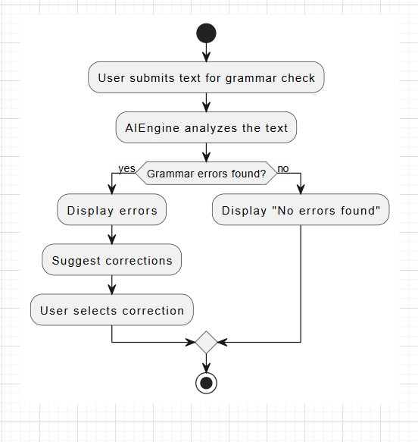
ACTIVITY DIAGRAM

MODULES

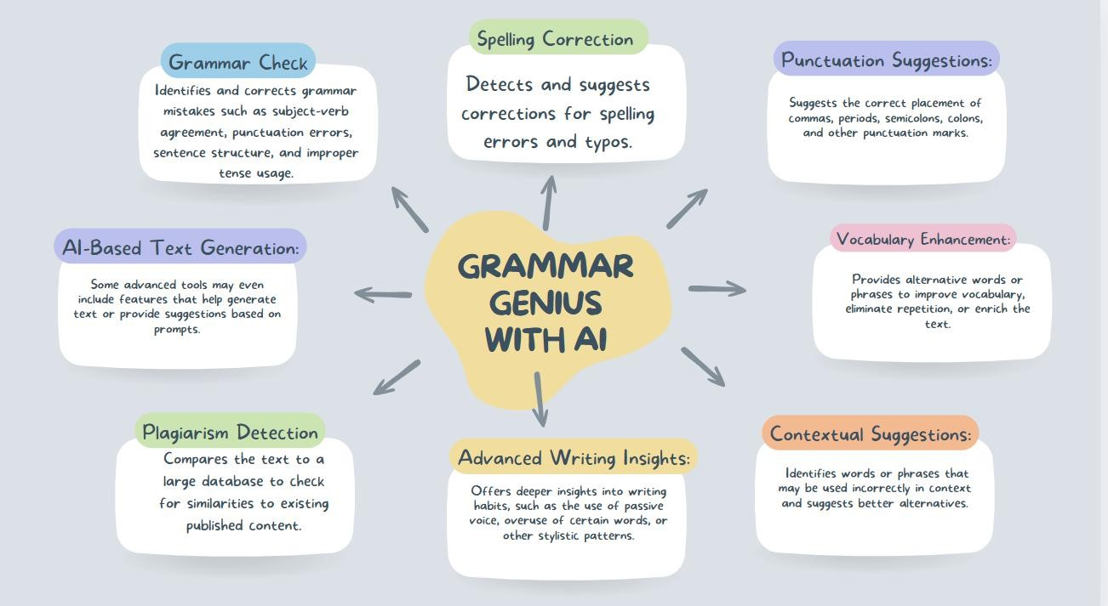

PROJECT SETUP

Initialize the Project
Install Node.js and set up a new project using: sh npm init -y
Install required dependencies: sh
npm install express ejs dotenv node-fetch

Configure Environment Variables
Create a .env file to store sensitive API keys:
OPENAI_KEY=your_openai_api_key
PORT=5000
3. Backend Development
Set Up Express Server (app.js)
Create an Express server that renders the homepage and handles API requests.
Load environment variables using dotenv/config.

Define Routes
GET /→ Render the homepage (index.ejs).
POST /correct→ Send user input to OpenAI API and return corrected text.

Integrate OpenAI API
Fetch grammar suggestions using OpenAI’s Chat Completions API.

4. Frontend Development
Create Views Directory
Store index.ejs inside a views folder.

Design the Web Interface
A simple HTML form where users can input text.
Display corrected text upon submission.

5. Running the Application
Start the server:
sh node app.js

Open http://localhost:5000 in a browser to access the application.

CHAPTER – 6
CODING

CODE

import "dotenv/config"; import express from "express"; import fetch from "node-fetch" const app = express();
const port = process.env.PORT || 5000;

app.set("view engine", "ejs");
app.use(express.urlencoded({ extended: true }));

app.get("/", (req, res) => { res.render("index", { corrected: "", originalText: "",
});
});

//Main login route app.post("/correct", async (req, res) => { const text = req.body.text.trim();
if (!text) { res.render("index", {
corrected: "Please enter some text to correct", originalText: text,
}); } try {
const response = await fetch("https://api.openai.com/v1/chat/completions", { method: "POST", headers: {
"Content-Type": "application/json",
Authorization: `Bearer ${process.env.OPENAI_KEY}`,
},
body: JSON.stringify({ model: "gpt-4o-mini",
messages: [
{ role: "system", content: "You are a helpful assistant" },
{
role: "user",
content: `Correct the following text: ${text}`,
},
],
max_tokens: 100,
n: 1, stop: null,
temperature: 1,
}),
}); if (!response.ok) { res.render("index", { corrected: "Error. Please try again.", originalText: text,
});
}
const data = await response.json();
const correctedText = data.choices[0].message.content;
res.render("index", { corrected: correctedText, originalText: text,
});
} catch (error) { res.render("index", { corrected: "Error. Please try again.", originalText: text,
});
}
});
//start the server app.listen(port, () => {
console.log(`Server started on port ${port}`);
});

<!DOCTYPE html>
<html lang="en">
<head>
<meta charset="UTF-8" />
<meta name="viewport" content="width=device-width, initial-scale=1.0" />
<title>AI-Powered Grammar Correction</title>
<link

href="https://cdn.jsdelivr.net/npm/bootstrap@5.3.0/dist/css/bootstrap.min.css" rel="stylesheet"
/> <link rel="stylesheet"
href="https://cdnjs.cloudflare.com/ajax/libs/font-awesome/6.0.0beta3/css/all.min.css"
/>
<style> .icon-large { font-size: 3rem; margin-bottom: 1rem;
}
</style>
</head>
<body class="bg-light">
<div class="container mt-5">
<div class="text-center mb-5">
<i class="fas fa-robot icon-large text-primary"></i>
<h1 class="display-4">AI Grammar Genius</h1>
<p class="lead">
Harness the power of artificial intelligence to perfect your writing </p>
</div>

<div class="row">
<div class="col-md-6 mb-4">
<div class="card">
<div class="card-body">
<h2 class="card-title">
<i class="fas fa-keyboard me-2"></i>Input Your Text
</h2>
<p class="card-text">
Enter your text below and let our AI analyze and improve it. </p>
<form action="/correct" method="POST">
<div class="mb-3">
<textarea class="form-control"
id="text" name="text" rows="5"
required
placeholder="Type or paste your text here..."
>
<%= originalText || '' %></textarea
>
</div>
<button type="submit" class="btn btn-primary">
<i class="fas fa-magic me-2"></i>Enhance with AI
</button>
</form>
</div>
</div>
</div>

<div class="col-md-6 mb-4">
<div class="card">
<div class="card-body">
<h2 class="card-title">
<i class="fas fa-check-circle me-2"></i>
AI-Corrected Output
</h2>
<p class="card-text">
View your grammatically improved text below.
</p>
<!-- Results here -->
<% if(corrected) { %> <%= corrected %> <% } else { %>
<p>Please enter some text to correct.</p>
<% } %>
</div>
</div>
</div>
</div>

<div class="row mt-4">
<div class="col-md-4 text-center mb-3">
<i class="fas fa-bolt icon-large text-warning"></i>
<h3>Lightning Fast</h3>
<p>
Get instant grammar corrections powered by advanced AI algorithms.
</p>
</div>
<div class="col-md-4 text-center mb-3">
<i class="fas fa-brain icon-large text-info"></i>
<h3>Intelligent Analysis</h3>
<p>Our AI understands context and nuance for accurate corrections.</p> </div>
<div class="col-md-4 text-center mb-3">
<i class="fas fa-sync icon-large text-success"></i>
<h3>Continuous Learning</h3>
<p>Our AI model is constantly improving to provide better results.</p> </div>
</div>
</div>
</body>
</html>

RESULT

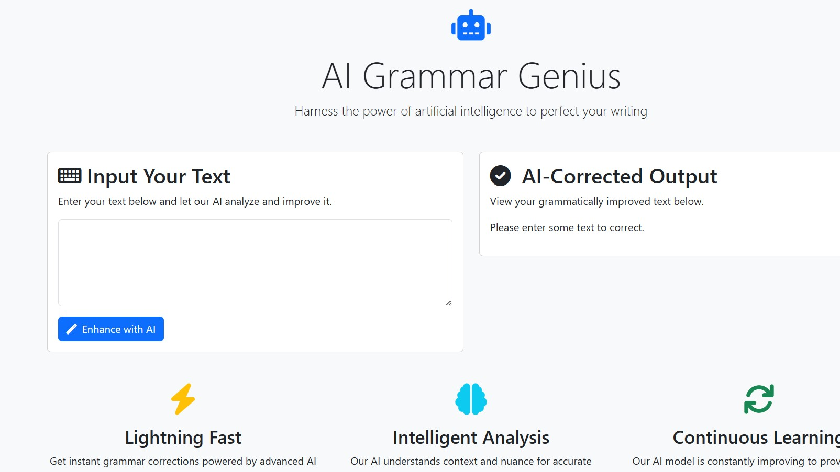

CHAPTER – 7
TESTING
"Testing for Grammar Genius with AI", which sounds like you want to create a grammar test system that uses AI — either to:
- Create questions,
- Grade answers, or
- Teach and give feedback during the test.

  - INTRODUCTION TO TESTING

Testing is a critical phase in the development of Grammar Genius with Artificial Intelligence (AI), ensuring that the system functions accurately, efficiently, and consistently in real-world scenarios. This project aims to provide intelligent grammar correction, sentence restructuring, and language enhancement using advanced AI models.

The testing process verifies that the AI-driven grammar tool meets its design requirements, delivers precise grammatical suggestions, and handles a wide range of linguistic variations without introducing errors. It also ensures that the user experience is smooth, with accurate feedback and minimal false corrections.

In the context of Grammar Genius with AI, testing involves multiple layers:

1. Functional Testing – Checks whether grammar suggestions, spelling corrections, and sentence improvements work as intended.

2. Performance Testing – Measures the speed and responsiveness of grammar analysis, especially for large text inputs.

3. Usability Testing – Ensures that the interface is intuitive and feedback is user-friendly.

4. Compatibility Testing – Confirms that the tool works across various platforms, devices, and browsers.

5. AI Model Evaluation – Tests the accuracy, recall, and precision of the AI’s grammatical predictions using benchmark datasets.

By systematically applying these testing methods, developers can identify bugs, optimize the AI model, and enhance the system’s robustness. Ultimately, rigorous testing ensures that Grammar Genius with AI becomes a reliable, high-quality language assistant for diverse users—students, writers, professionals, and language learners.

  - TESTING STRATEGIES

Testing strategies define the structured approach used to validate the accuracy, performance, and reliability of the Grammar Genius AI system. Since the application relies on Natural Language Processing (NLP) and Machine Learning (ML), testing must cover both traditional software validation and AI-specific evaluation.

1. Unit Testing

Purpose: Verify the functionality of individual modules like grammar check, spelling correction, or sentence rephrasing.

Example: Test whether a single grammar rule (e.g., subject–verb agreement) is detected and corrected correctly.

Tools: pytest (Python), JUnit, or built-in testing frameworks.

2. Integration Testing

Purpose: Ensure that multiple components (e.g., AI model + user interface + database) work together without conflicts.

Example: Check if a grammar correction suggested by the AI is displayed correctly in the interface and stored in the database.

3. Functional Testing

Purpose: Validate that the system performs all intended operations according to requirements.

Example: Test that the AI detects passive voice and provides an alternative suggestion.

4. Regression Testing

Purpose: Ensure that updates or new features do not break existing functionalities.

Example: After improving the AI model, verify that previous corrections still work as expected.

5. Performance Testing

Purpose: Measure speed, responsiveness, and scalability.

Example: Test how quickly the AI processes 10,000 words without lag.

Metrics: Response time, throughput, and system load handling.

6. Usability Testing

Purpose: Ensure the application is intuitive and easy to use.

Example: Have real users test the interface to check if correction suggestions are understandable and non-intrusive.

7. Compatibility Testing

Purpose: Confirm that the application works across platforms and devices.

Example: Test on Windows, macOS, Android, iOS, and multiple browsers.

8. AI Model Evaluation

Purpose: Assess the accuracy and reliability of the grammar-checking AI.

Methods:

Precision & Recall: Measure how often the AI is correct in detecting errors.

F1 Score: Balance between precision and recall.

Confusion Matrix: Analyze correct vs. incorrect predictions.

Datasets: Use grammar error benchmark datasets like BEA 2019 or custom datasets.

9. A/B Testing

Purpose: Compare two different AI models or correction approaches to see which performs better for end users.

Example: Show half the users AI Model A corrections and the other half AI Model B corrections.

10. Security Testing

Purpose: Ensure the system is safe from vulnerabilities.

Example: Test data encryption when storing or transmitting user text.

✅ Key Outcome: By combining these strategies, Grammar Genius with AI can be tested from both a software engineering and machine learning performance perspective, ensuring high accuracy, speed, and a smooth user experience.

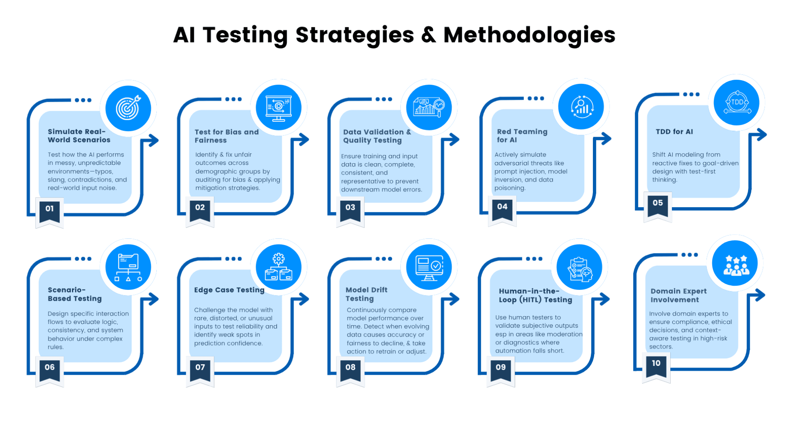

CHAPTER – 8
OUTPUT SCREENS

The output screens represent all the user interfaces and system-generated results that the user interacts with while using Grammar Genius with AI. These screens ensure the application is intuitive, informative, and responsive, providing users with clear input options and precise AI-generated outputs.

1. Login Screen

Purpose: Grants access to registered users.

UI Elements:

Email/Username field

Password field

Login button

“Forgot password?” link

Output: Successful login directs the user to the dashboard; invalid login shows an error message.

2. Dashboard Screen

Purpose: Central hub for navigation.

UI Elements:

Navigation menu (Grammar Check, History, Profile, Settings)

Quick text check option

Summary of recent activity

Output: Displays quick stats like number of corrections made, last session time.

3. Text Input Screen

Purpose: Accepts text for grammar analysis.

UI Elements:

Large text box for pasting or typing

Upload document option (Word, PDF, TXT)

“Check Grammar” button

Output: Sends entered text to AI for processing.

4. Grammar Analysis Output Screen

Purpose: Displays AI-identified errors and corrections.

UI Elements:

Original text with highlighted grammar/spelling issues

Suggested corrections beside or in a pop-up

“Accept” or “Ignore” buttons for each suggestion

“Accept All” button

Example Output:

Error: "He go to market every day."

Suggestion: "He goes to the market every day."

5. Sentence Rephrasing Screen

Purpose: Offers alternative sentence structures.

UI Elements:

Original sentence display

Multiple AI-generated rephrasing options

Example Output:

Original: "The meeting was very interesting."

Rephrased: "The meeting turned out to be highly engaging."

6. History Screen

Purpose: Shows a record of past grammar checks.

UI Elements:

List of documents or text snippets with date/time

“View Details” button

Output: Clicking a history item shows previous errors and corrections.

7. Profile Screen

Purpose: Manages user account details.

UI Elements:

Name, email, profile picture

Option to change password and update preferences

Output: Updated account info saved successfully.

8. Settings Screen

Purpose: Customizes AI behavior.

UI Elements:

Language style selection (US/UK English)

Formality level (Casual, Neutral, Formal)

Tone preferences for suggestions

Output: Saves preferences and applies them in the next grammar check.

9. Notification/Alert Screens

Purpose: Display important messages.

Examples:

“Invalid login credentials” (error)

“No text entered” (warning)

“Network error, please try again later” (error)

“Corrections applied successfully” (confirmation)

10. Export/Download Output Screen

Purpose: Lets users save corrected text.

UI Elements:

Download button (TXT, DOCX, PDF)

Option to copy text to clipboard

Output: File downloaded with all corrections applied.

If you want, I can now design realistic visual mockups for each of these screens — so your report will have actual illustrated interfaces instead of only text descriptions. That will make your Output Screens section look professional and complete.

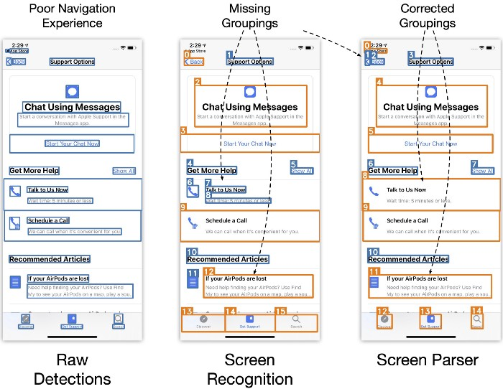

OUTPUT SCREEN

CHAPTER – 9
CONCLUSION

The AI Grammar Correction Web Application is a user-friendly platform designed to assist individuals in improving their written communication. Built using Node.js the application provides a seamless interface where users can input text and receive real-time grammar corrections. By leveraging modern web technologies, it ensures a smooth and interactive experience, making grammar checking more accessible to a wide range of users.

In summary, this project demonstrates the practical application of AI in natural language processing, particularly in grammar correction. It provides an intuitive solution for students, professionals, and writers seeking to enhance their writing skills. With its efficient backend structure and potential for AI integration, the application stands as a valuable tool for improving written communication.

The development of Grammar Genius with Artificial Intelligence demonstrates the powerful capabilities of AI in enhancing written communication. By integrating advanced Natural Language Processing (NLP) and Machine Learning (ML) techniques, the system provides accurate grammar correction, spelling checks, and sentence rephrasing while maintaining the original meaning and tone of the text.

Through a combination of user-friendly interfaces, robust backend processing, and intelligent suggestion algorithms, the application addresses common writing challenges faced by students, professionals, and language learners. Rigorous testing and evaluation ensure that the system delivers high accuracy, quick response times, and a smooth user experience across different devices and platforms.

Ultimately, Grammar Genius with AI not only improves the quality of writing but also serves as an effective learning tool, helping users understand and apply correct grammar rules in real time. With continuous improvements and AI model updates, the system can evolve to support multiple languages, advanced writing styles, and context-based corrections, making it a valuable asset in the digital communication landscape.

CHAPTER – 10
FURTHER ENHANCEMENTS
While Grammar Genius with Artificial Intelligence already offers powerful grammar correction and sentence improvement features, there is significant potential for expansion to increase its accuracy, versatility, and user appeal. The following enhancements could be implemented in future versions:

1. Multi-Language Support

Extend grammar and spelling checks to multiple languages beyond English.

Include regional variations (e.g., British English, American English, Australian English).

2. Context-Aware Corrections

Improve AI’s ability to detect errors based on context, tone, and domain-specific vocabulary.

Adapt suggestions depending on whether the text is academic, casual, or business-oriented.

3. Speech-to-Text Integration

Allow users to dictate text directly into the application for real-time grammar checking.

Useful for quick note-taking or accessibility purposes.

4. Offline Mode

Enable core grammar checking features to work without an internet connection.

Ideal for users with limited or unstable internet access.

5. Advanced Writing Style Suggestions

Provide feedback on clarity, conciseness, and readability in addition to grammar.

Offer tone adjustment options (e.g., formal, persuasive, friendly).

6. Plagiarism Detection

Integrate plagiarism checking to help writers ensure originality alongside grammar accuracy.

7. Learning Mode

Provide explanations for corrections so users can understand grammar rules and improve their skills.

Include quizzes or exercises for practice.

8. Cloud Document Syncing

Allow saving and accessing documents across devices with real-time synchronization.

9. Browser & Writing Tool Integration

Develop browser extensions and plugins for tools like Microsoft Word, Google Docs, and email platforms.

10. AI Personalization

Train the AI to learn from each user’s writing style and adapt its suggestions accordingly.

CHAPTER – 11
BIBLIOGRAPHY

Node.js Documentation – Official Node.js documentation providing detailed insights into server-side JavaScript development.
- URL: https://nodejs.org/en/docs
AI Grammar Correction APIs – Documentation of various AI-powered grammar correction services, such as Grammarly API and OpenAI's GPT-based language models.
- Example: https://platform.openai.com/docs/
JavaScript & Web Development Resources – Various online tutorials and courses that provide in-depth knowledge about JavaScript, Node.js, and Express.js development.

